User Guide:
Salesforce End of Tenancy

Version History
Version | Description of Change | Author | Date
0.1 | First Draft | Nikki Papenfus | 05/12/2023

Table of Contents
1. Overview 3
2. How to Create an EOT 6
3. Looking at the EOT 6
4. End of Tenancy Tasks 7
4.1 Where Do I Find My Tasks? 7
4.2 The Task at a Glance 8
4.3 Task Statuses 9
4.4 Starting a Task 9
4.5 Completing a Task 10
4.6 Setting Tasks to N/A 11
4.7 Reopening a Closed Task 11
4.8 Tasks with Expected Delays 12
4.9 Overdue Tasks 14
4.10 Completed Tasks 14
5. How to Cancel or Close an EOT 15
6. Reports 15
7. EOT Owners 15
7.1 Approving Requests to Cancel or Close an EOT 15
7.2 Identifying EOTs at Risk 15
7.3 Void Cost & KPI report. 15

Overview
To do.
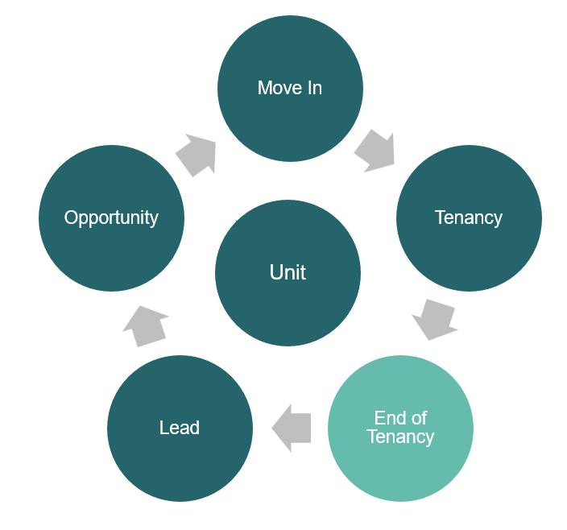

End of Tenancy Phases & Tasks

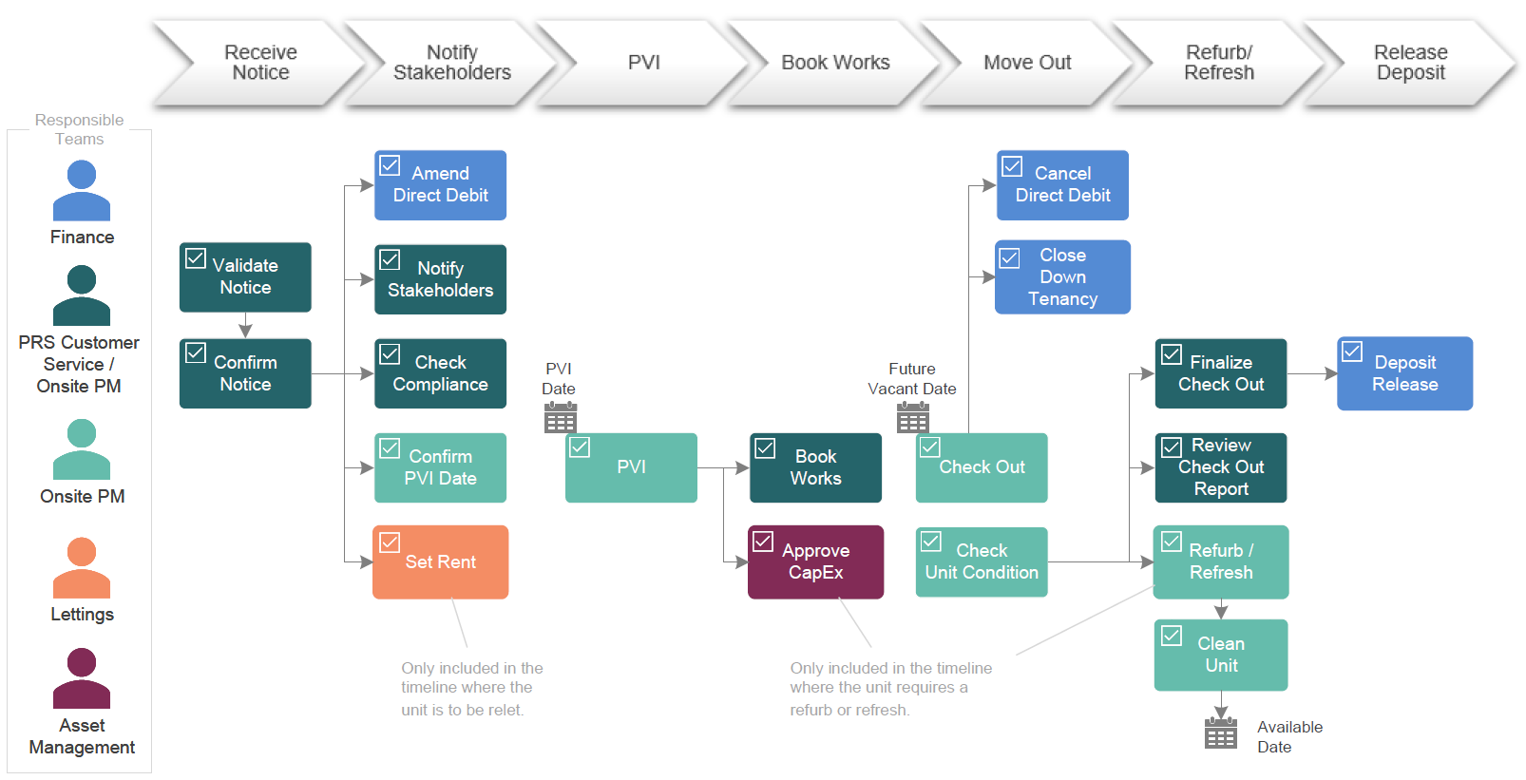

End of Tenancy Phases & Tasks (Simple Version)

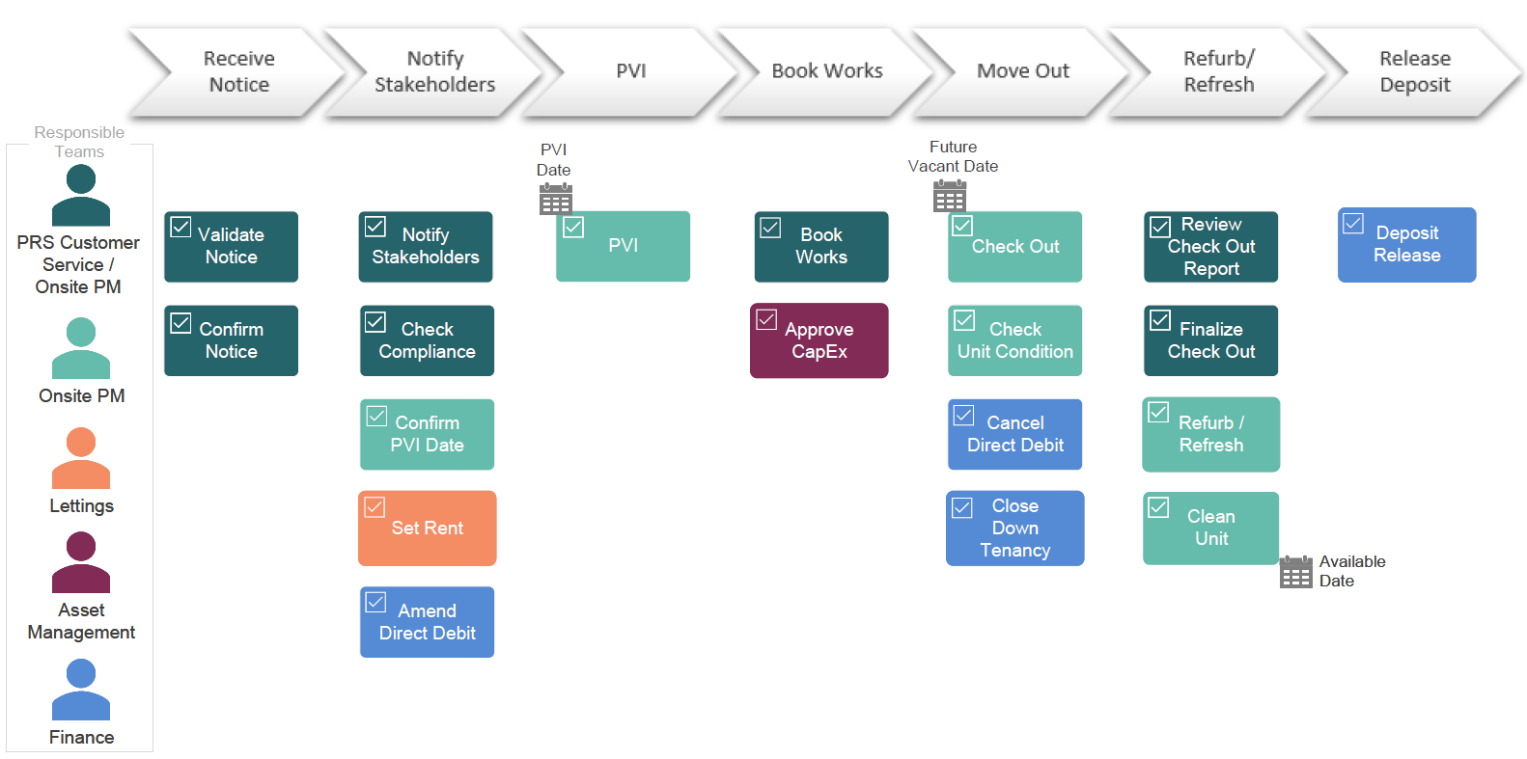
Interaction between End of Tenancy & other Tenancy-Related Objects in Salesforce
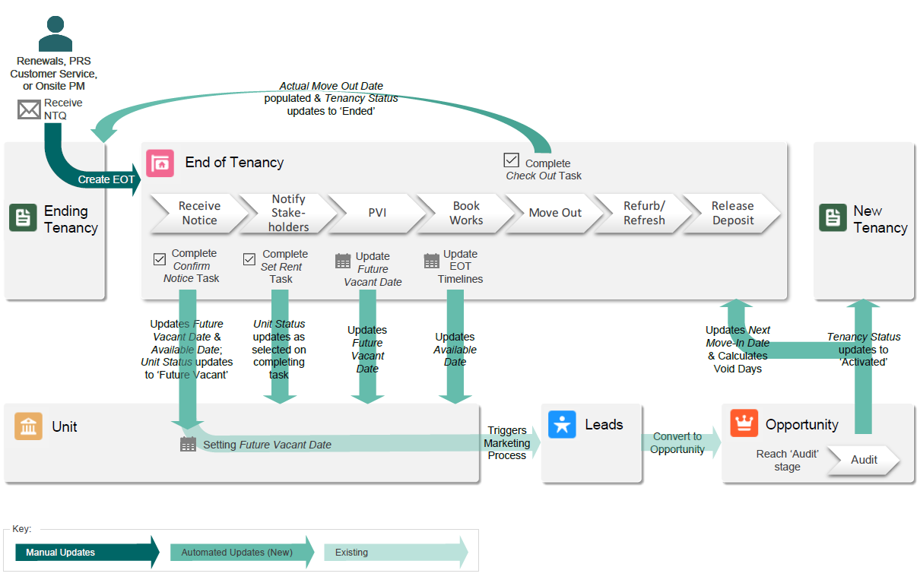

How to Create an EOT
To do.

Looking at the EOT
To do.

End of Tenancy Tasks

Where Do I Find My Tasks?
End of Teancy tasks that ready to be worked on can be found on the Salesforce Home page.
- My EoT Tasks for Today displays all tasks assigned to you & are ready to be worked on.
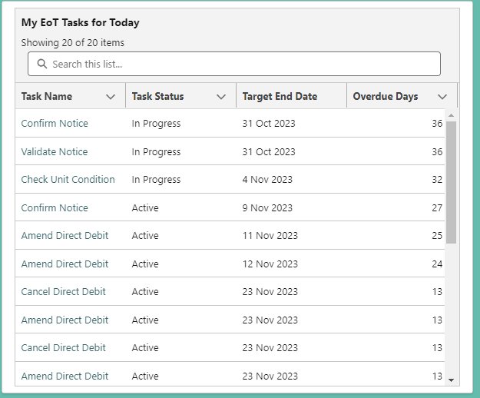
Click on the task name to open the task details.
The most urgent tasks are displayed at the top of the list.
- My Team’s Unassigned EoT Tasks for Today displays all tasks for which your team is responsible and are ready to be worked on, but have not yet been assigned to anyone.
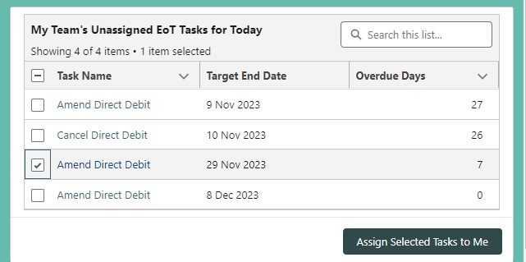
Shortcut to assign one or more tasks to yourself.
Task lists can also be found under the End of Tenancy Tasks menu item.

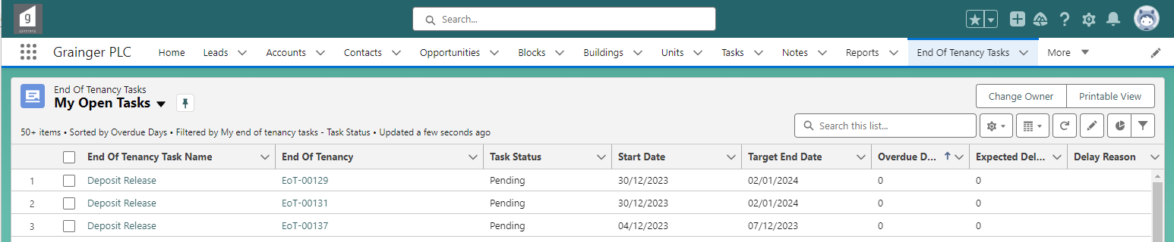

The Task at a Glance
Task Status: Active tasks are ready to be worked on once the start date is reached.
Target End Date:
Date by which the task should be completed.
Start Date: Date when work should begin on the task.

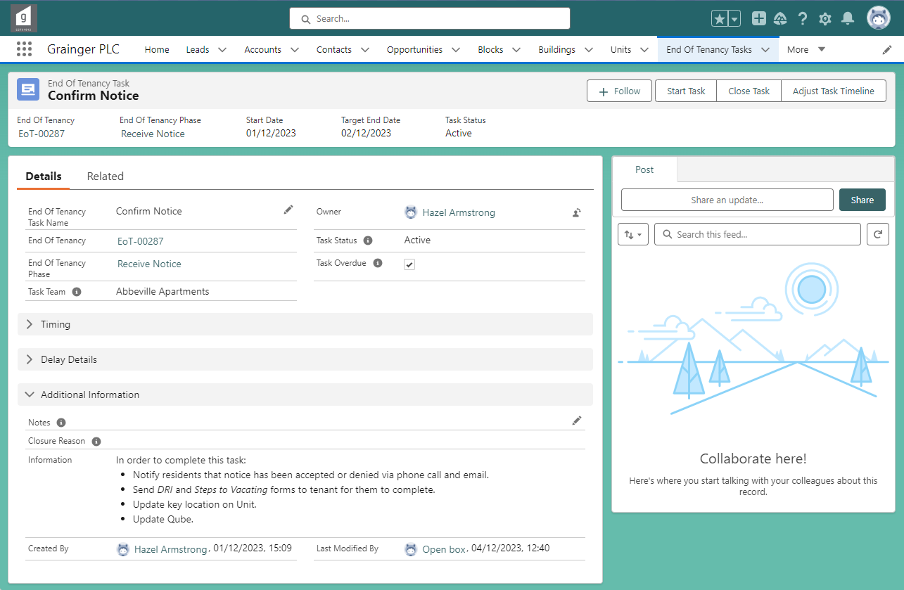
Owner: Person responsible for completing the task.
Tasks are initially assigned to a Task Team and should be allocated to an individual as start date approaches.
Files: Documents & emails can be linked to a task in the Related tab.
Information: Guidance on what needs to be done before the task can be marked as complete.
Notes: Capture any relevant notes about task progress; these may appear in reports.

A task’s Start Date and Target End Date will automatically update as work progresses on the End of Tenancy.
- Where a task is dependent on the Future Vacate Date or PVI Date, the task dates will automatically update when these dates changes.
- Where a task is dependent on other prerequisite tasks being completed, the task dates will automatically update as the prerequisite tasks are completed or where any expected delays are captured.

Task Statuses
Tasks progress through a sequence of statuses:
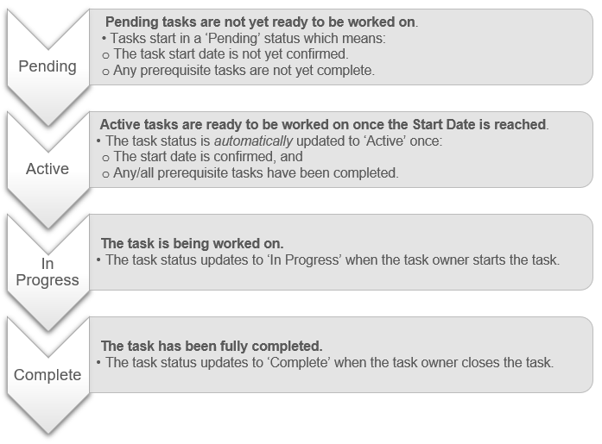
Alternately, where a task is not applicable for a particular End of Tenancy, the task status can be set to ‘N/A’. See Setting Tasks to N/A.

Starting a Task
Select ‘Start Task’
If you have started working on a task, but it is not yet complete:
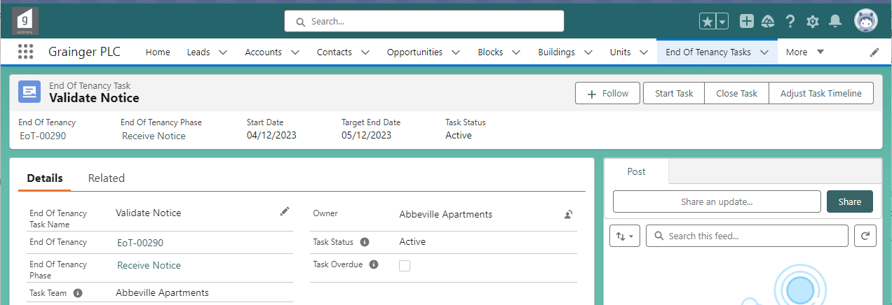
You will be automatically assigned as the task Owner
& the task status will be set to ‘In Progress’.

Completing a Task
Select ‘Close Task’
Once a task is complete:
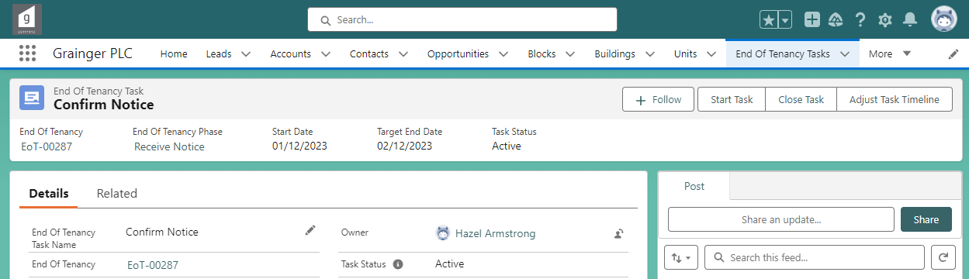
Select ‘Complete’, then ‘Next’.
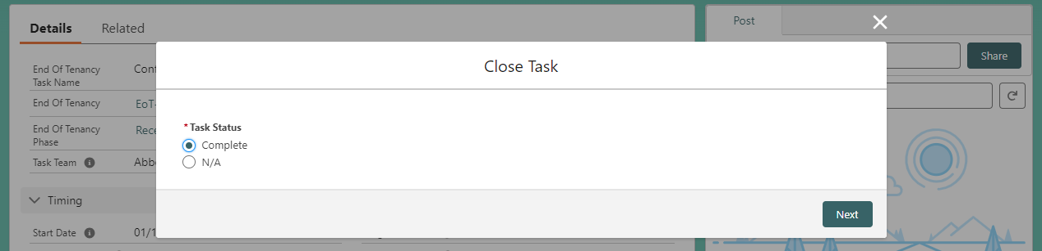
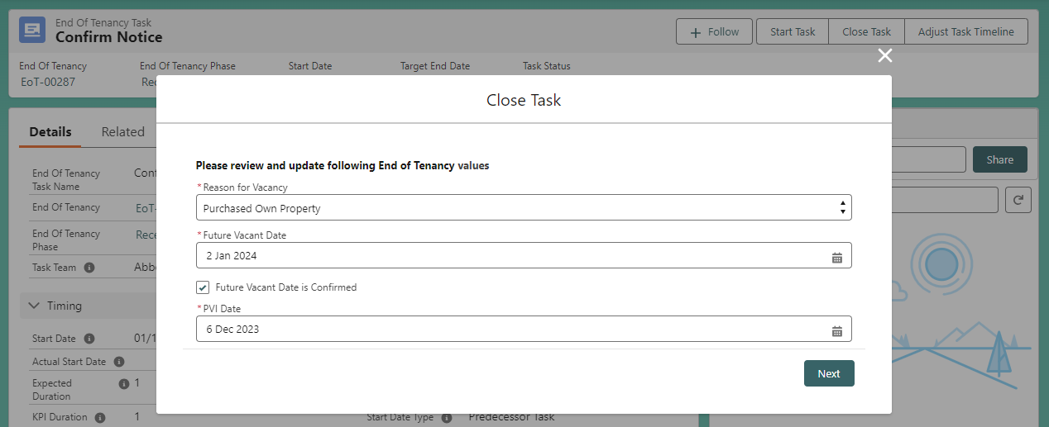
Some tasks require specific End of Tenancy information to be reviewed & updated when closing the task.
If a task is completed more than 2 days late (i.e. more than 2 days after the Target Due Date), then a reason for the delayed completion will also be required when completing the task.

You don’t need to start a task before completing it; tasks can be set straight to complete.

Setting Tasks to N/A
Where a task is not relevant for a particular End of Tenancy, the task status can be set to ‘N/A’.
- ‘N/A’ tasks are not included in the End of Tenancy timeline.
- For example, Approve Capex tasks may be set to ‘N/A’ if the refurb or refresh costs are below the threshold requiring approval.
Select ‘Close Task’
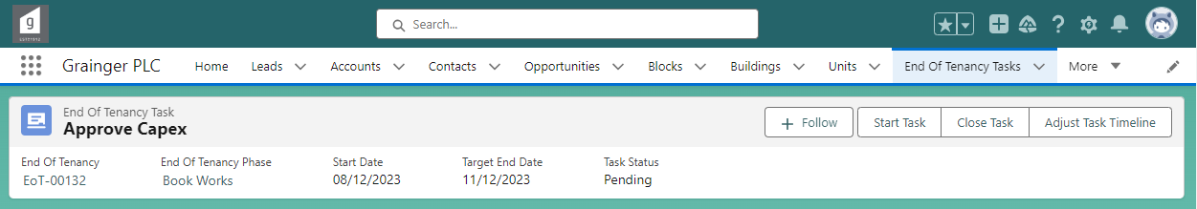
Select ‘N/A’
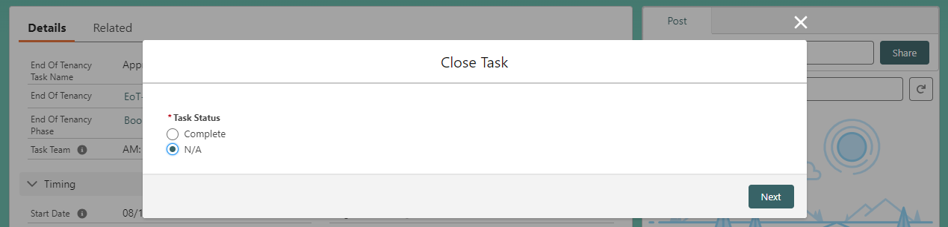
You will be required to enter a reason why the task is not applicable for this End of Tenancy on the next screen.

Reopening a Closed Task
Select ‘Open Task’
If a task’s status was set to ‘Complete’ or ‘N/A’ by mistake:
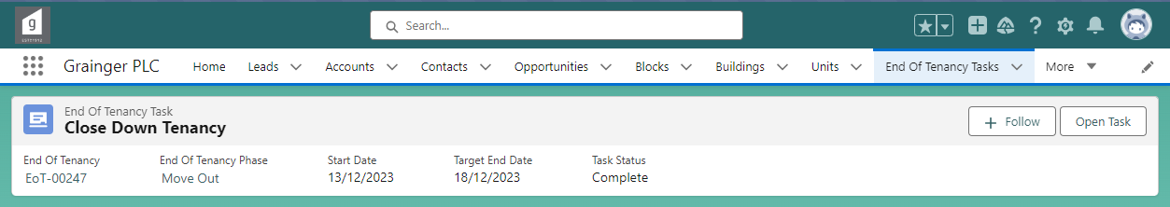
Set the task back to the previous status.
See Task Statuses for more information.
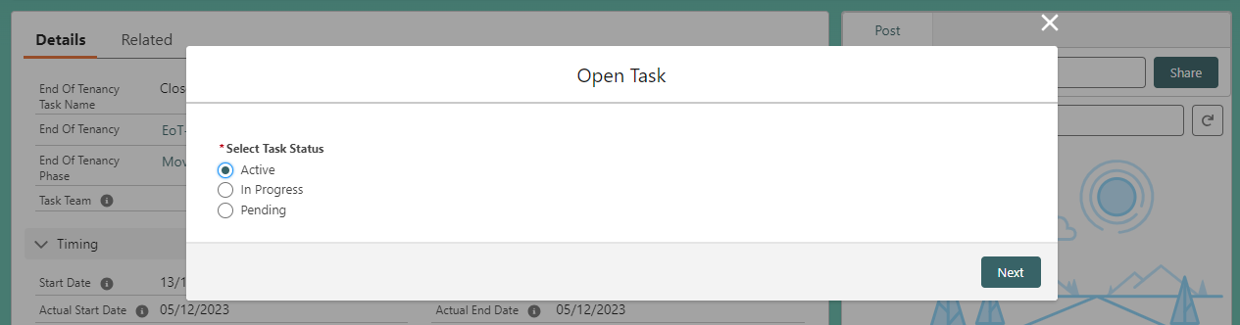

Tasks with Expected Delays
Where a task is likely to be delayed, the expected delay can be incorporated into the task dates, and overall End of Tenancy timelines, by adjusting the task timeline.
- The End of Tenancy’s Available Date, Completion Date as well as any other tasks that are dependent on the delayed task, will be automatically updated to reflect the delayed timelines.
Select ‘Adjust Task Timeline’
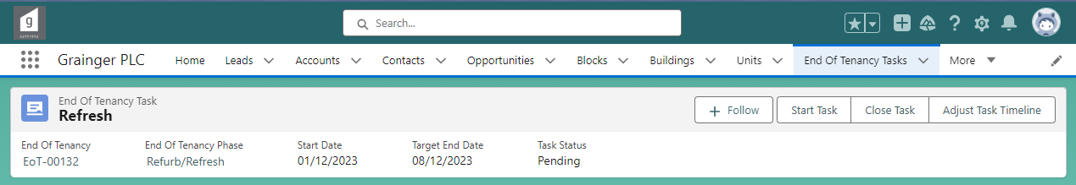
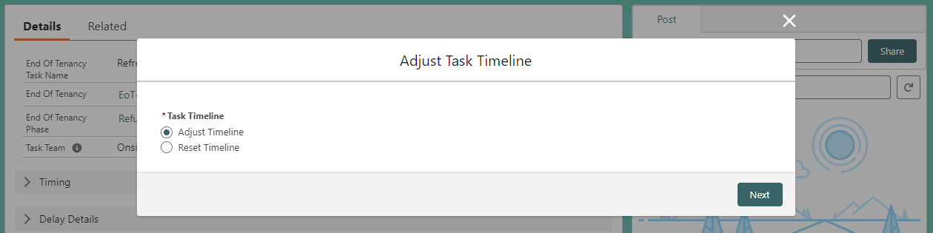
The task duration (i.e. number of days that the task is expected to take to complete) can be updated by selecting either a new Expected Duration or a new Expected End Date.
Select ‘Adjust Timeline’

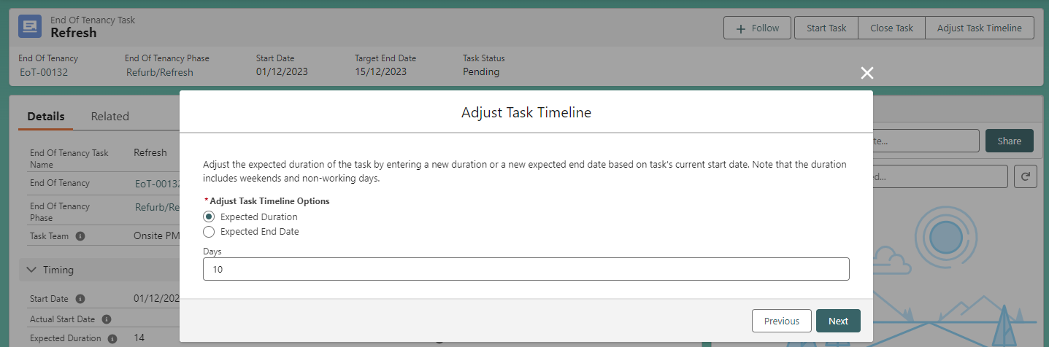
A reason for the expected delay will be required on the next screen.
Note duration includes weekend & non-working days.
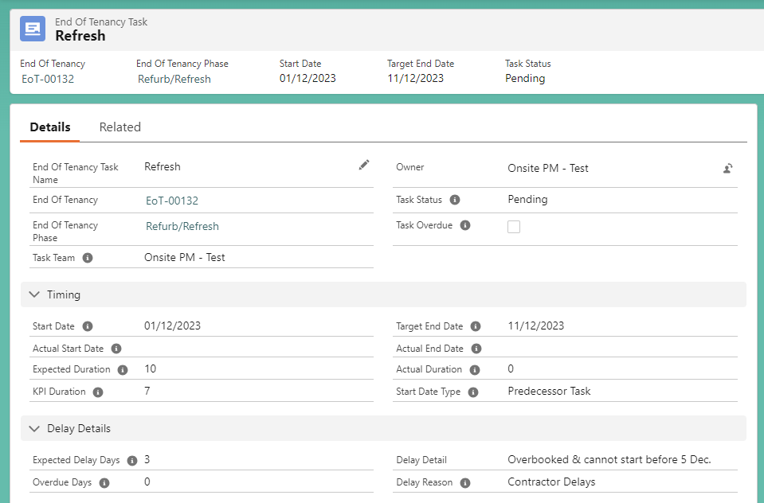
The task’s KPI Duration reflects the original task duration before any adjustments to the task timeline.
Expected Delay Days: The number of days by which the task is delayed.
The task’s Expected Duration is updated based on the information entered, and the Target End Date is updated accordingly.

A task’s timeline can also be adjusted to be completed ahead of schedule. No delay reason needs to be entered when shortening a task’s timelines.

To update any of the expected delay details: Select ‘Adjust Task Timeline’ & follow the above screens again to update the delay information already entered.
Select ‘Adjust Task Timeline’
To remove an expected delay:
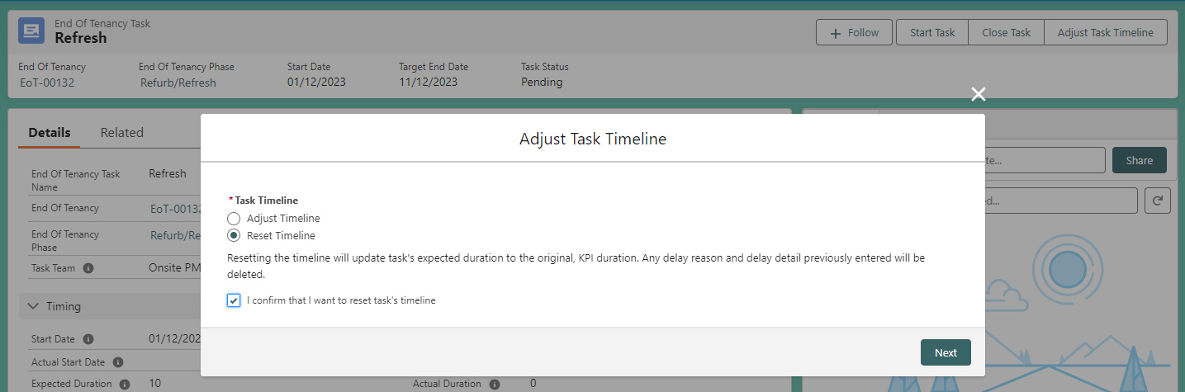
Select ‘Reset Timeline’ & tick the box confirming that all delay information should be deleted.
All delay information is removed from the task on selecting ‘Next’.
The task duration is reset to the original, KPI Duration.

Overdue Tasks
To do.

Completed Tasks
To do.
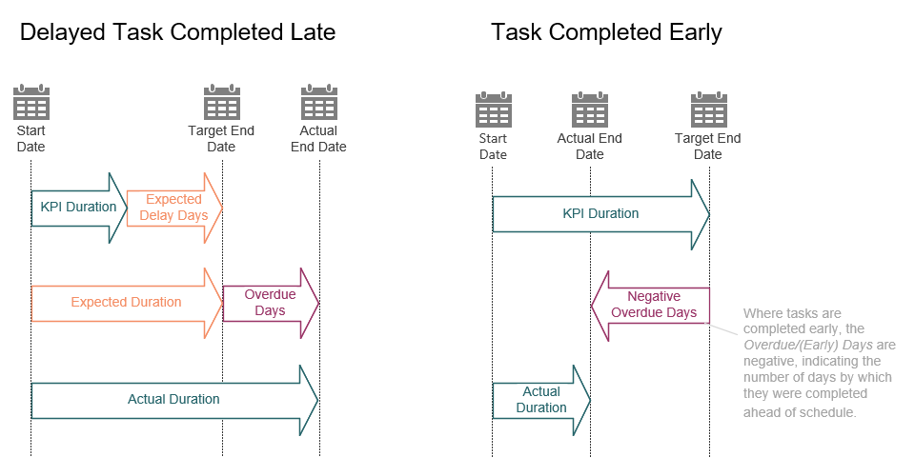

How to Cancel or Close an EOT
To do.

Reports
To do.

EOT Owners

Approving Requests to Cancel or Close an EOT
To do.

Identifying EOTs at Risk
To do.

Void Cost & KPI report.
To do.

